August 30, 2022 Assessment

Question A

DROP TABLE IF EXISTS Employee;

-- Question A

CREATE TABLE Employee (

id INT NOT NULL,

Name VARCHAR(25),

Joining_dt date,

Manager_id INT,

Dept VARCHAR(25),

Salary Decimal(8,2)

);

INSERT INTO

Employee(id, Name, Joining_dt, Manager_id, Dept, Salary)

VALUES

(1, 'abc', '01-01-2021', 2, 'IT', 10000),

(2, 'bcd', '01-01-2020', 3, 'IT', 20000),

(3, 'dce', '01-01-2020', 4, 'Admin', 10000),

(4, 'xyz', '01-01-2022', 0, 'IT', 20000),

(5, 'pqr', '01-01-2022', 2, 'IT', 15000);

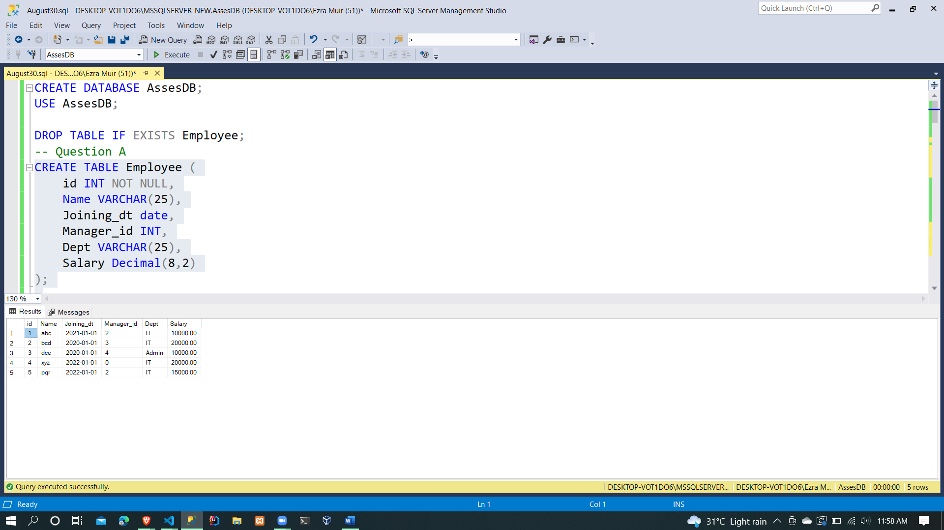

Output 1

SELECT Name, Manager_id

FROM Employee;

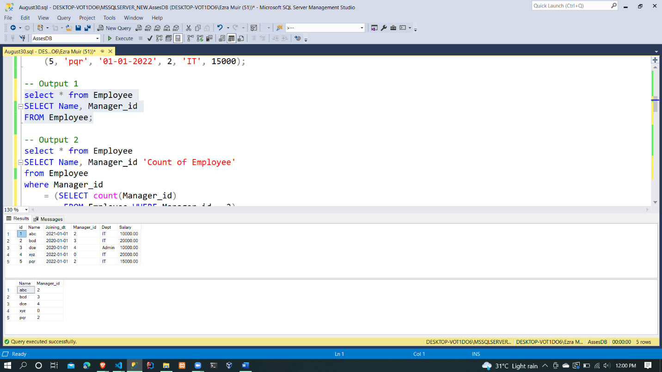

Output 2

SELECT Name, Manager_id 'Count of Employee'

from Employee

where Manager_id

= (SELECT count(Manager_id)

FROM Employee WHERE Manager_id = 2)

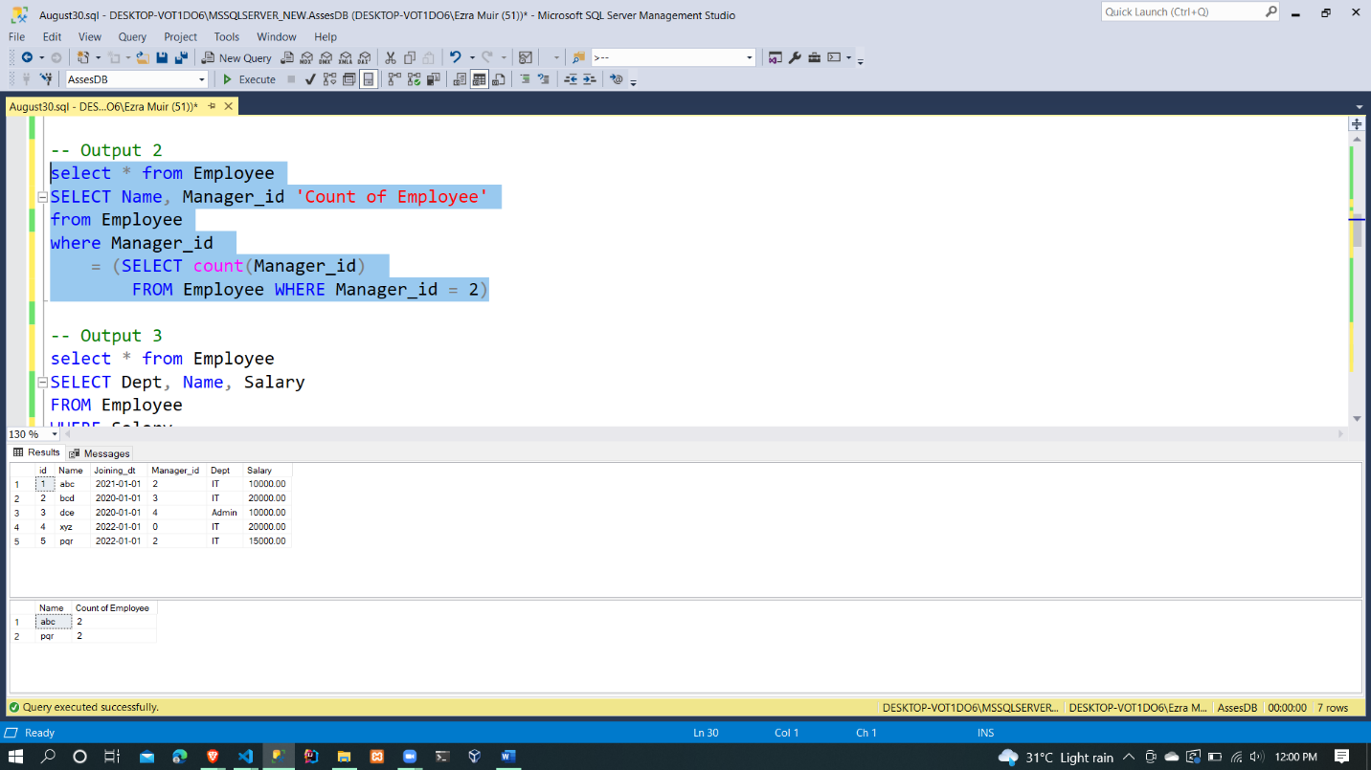

Output 3

SELECT Dept, Name, Salary

FROM Employee

WHERE Salary

= (SELECT MAX(Salary)

FROM Employee) and Dept IN('IT','Admin')

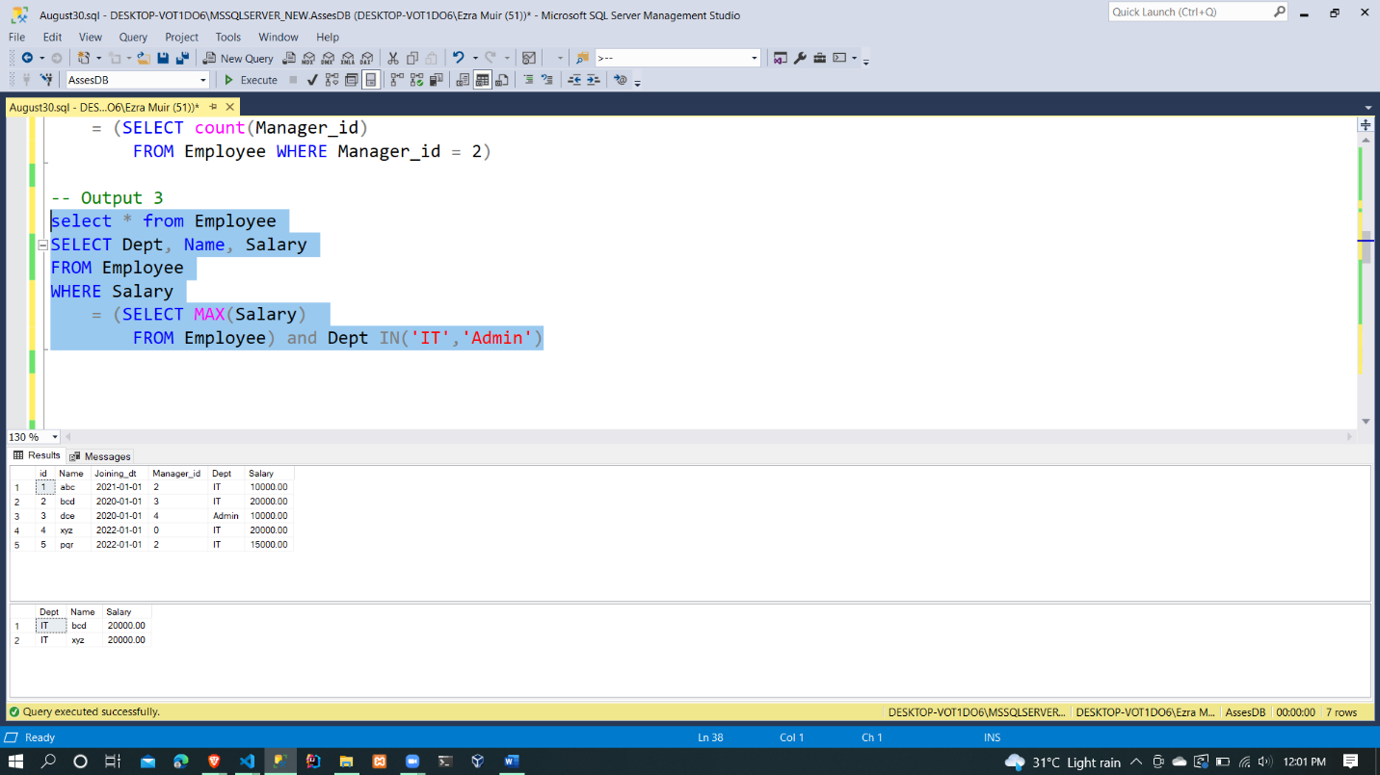

Question B

DROP TABLE IF EXISTS Account;

-- Question B

CREATE TABLE Account (

id INT NOT NULL,

Name VARCHAR(25),

Status VARCHAR(25),

Tran_id INT NOT NULL,

Tran_type VARCHAR(1),

Tran_amt DECIMAL(8,2),

Tran_dt date

);

INSERT INTO

Account(id, Name, Status, Tran_id, Tran_type, Tran_amt, Tran_dt)

VALUES

(1, 'abc', 'act', 1, 'c', 500, '01-01-2022'),

(1, 'abc', 'act', 2, 'c', 500, '02-02-2022'),

(1, 'abc', 'act', 3, 'c', 500, '02-03-2022'),

(1, 'abc', 'act', 2, 'd', 500, '02-04-2022'),

(1, 'abc', 'act', 4, 'd', 500, '02-05-2022'),

(2, 'xyz', 'act', 1, 'c', 500, '01-01-2022'),

(2, 'xyz', 'act', 2, 'c', 500, '02-02-2022'),

(3, 'pqr', 'act', 3, 'c', 500, '02-03-2022'),

(3, 'pqr', 'act', 2, 'c', 1000, '02-04-2022'),

(4, 'suv', 'act', 4, 'c', 1000, '02-04-2022'),

(4, 'suv', 'act', 4, 'd', 500, '02-05-2022');

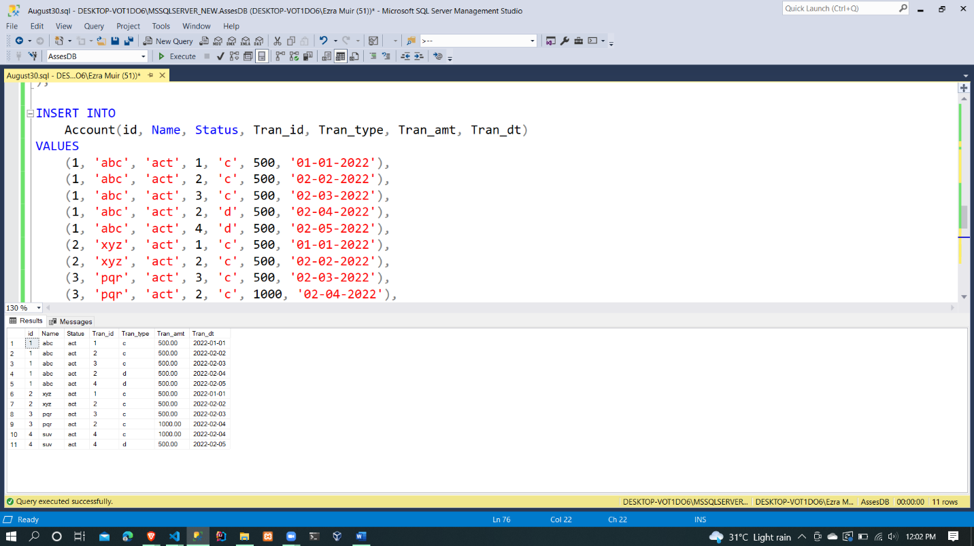

Output 1

SELECT TOP 1 *

FROM Account

WHERE Tran_type='c'

ORDER BY Tran_dt DESC;

SELECT TOP 1 *

FROM Account

WHERE Tran_type='d'

ORDER BY Tran_dt DESC;

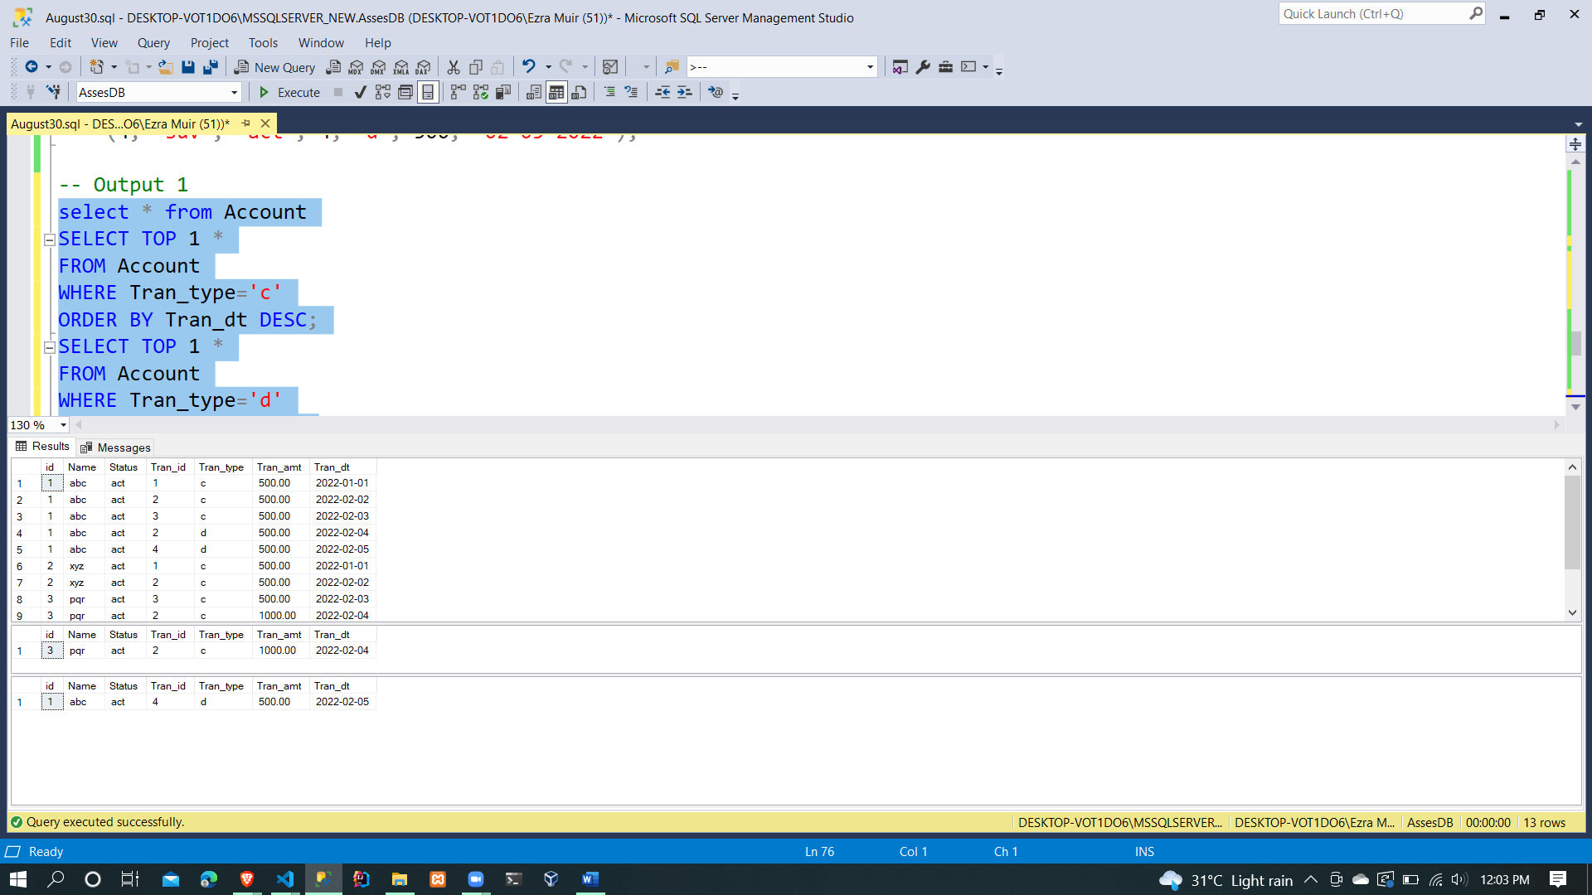

Output 2

SELECT DISTINCT id, Tran_amt 'sum(credit)', 'sum(debit)'

FROM Account

WHERE Tran_amt

=(Select Sum(Tran_amt) FROM Account WHERE Tran_type='c')

or Tran_amt

=(select SUM(Tran_amt) FROM Account WHERE Tran_type='d')